# Selenium IDE Testing – Borrowing Books

This testing scenario includes the borrowing a textbooks for our textbook sharing website. We are going using the selenium program to test whether each user story is able to meet their acceptance criteria.

The acceptance criteria for Borrowing Textbooks are:

* Search returns books when searching for Titles.
* ‘Contact’ button contains the correct Mail To link.

To borrow a textbook as a user, you must do the following steps:

1. Go to <http://bookbook.azurewebsites.net/bookbook/pages/homepage.php> and login as a user
2. Once logged in after being redirected to the homepage, search for a textbook on the search bar
3. Once entering in your preferred book, the search engine will look through our database to find any matches and display them (See Figure 2)
4. When you’ve found your book, click on the ‘Borrow Me’ button (See Figure 2)
5. This will open up your personal email program on your computer to be able to chat with the owner of the textbook via email (See Figure 3)

As seen in Figure 1, it shows Selenium program testing our case for Borrowing a Textbook. It captures each of the above steps and is able to run through it all without any failures.

After we have concluded that the Selenium test has successfully run without any problems, we must check if the user story has passed its acceptance criteria. Re-iterated earlier, Figure 1 shows the automated testing for both acceptance criteria as it searches for a textbook title, and contacts the owner of the textbook to communicate via email.

Figure 2 and 3 respectively show the same thing from the website interface. It shows the searching of ‘Selenium TestBook’ (See Figure 2). Once the textbook has been found the ‘Borrow Me’ button redirects the user to a personal email program for both parties to talk (See Figure 3).

# APPENDIX

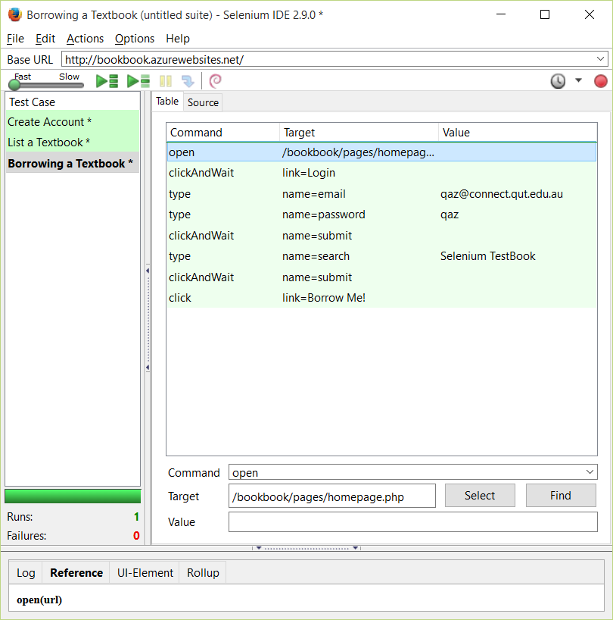

Figure 1

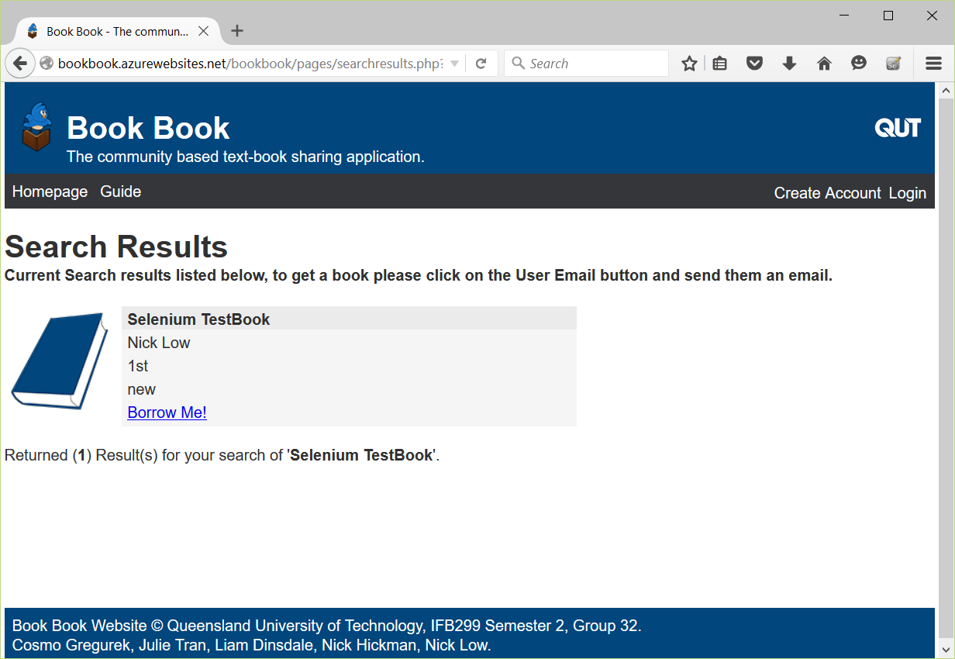

Figure 2

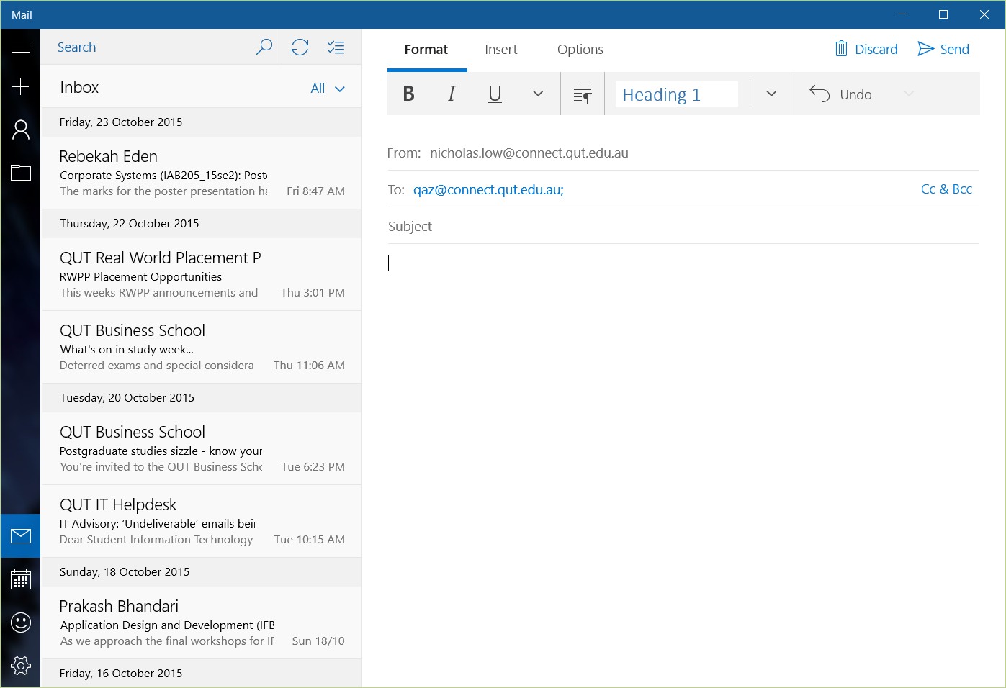

Figure 3